|  |
| --- |
| ** |

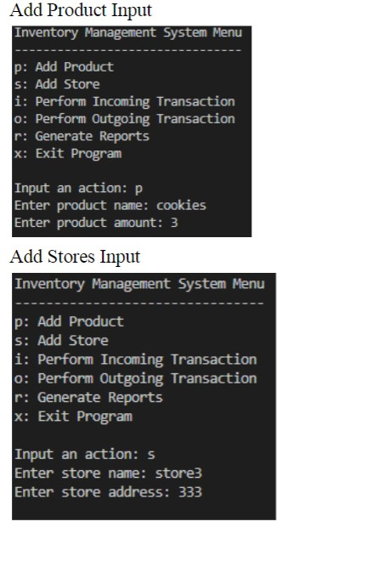

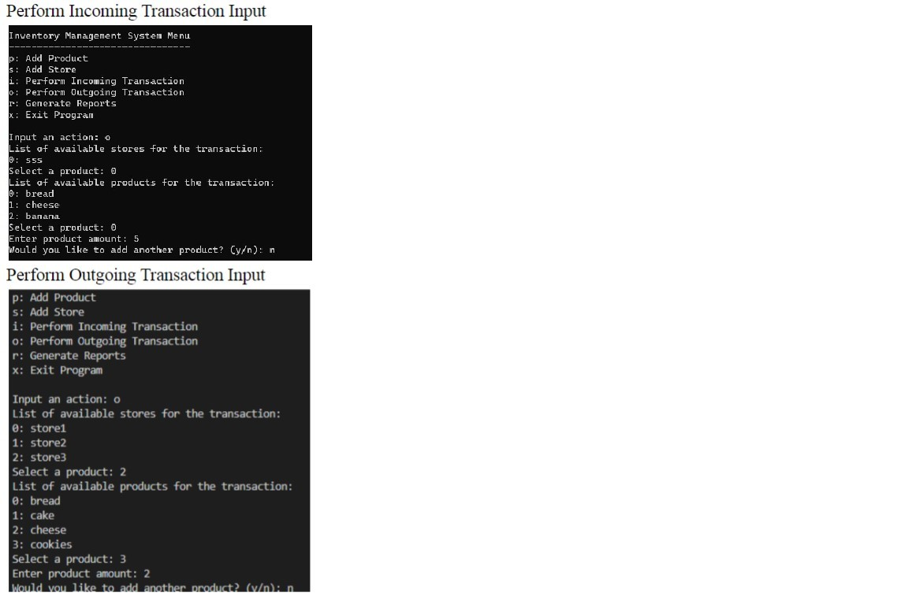

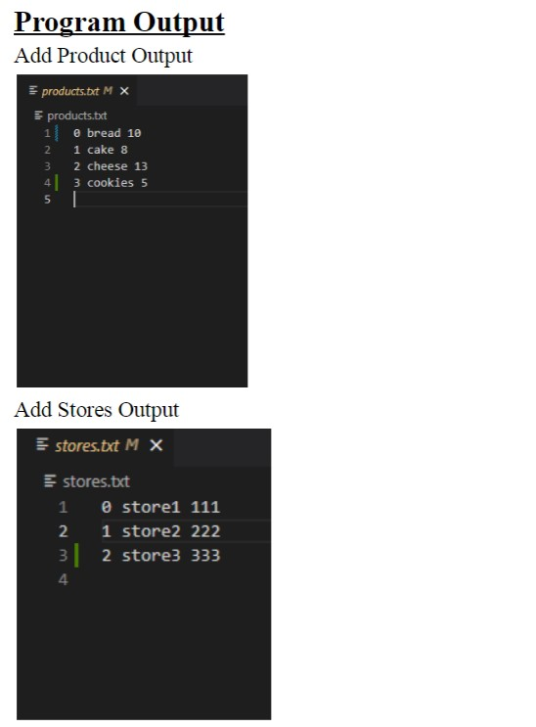

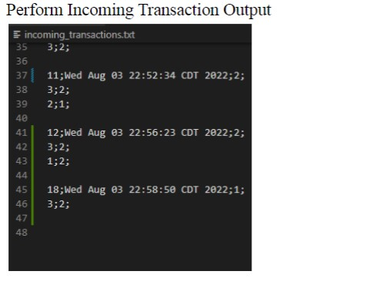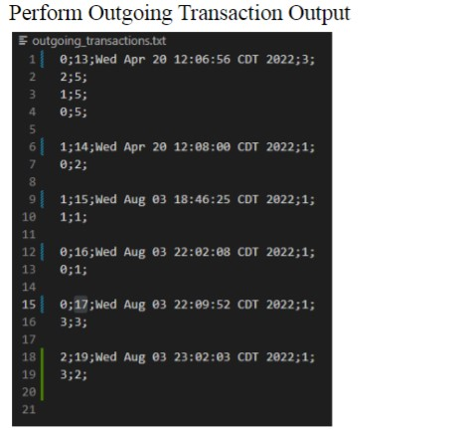

One sample report

|  |  |  |  |  |
| --- | --- | --- | --- | --- |
| This announcement is closed for comments |  |  |  |  |
| Search entries or author    read |  |  |  |  |